4 New Thanksgiving Traditions To Start with Your Family This Year
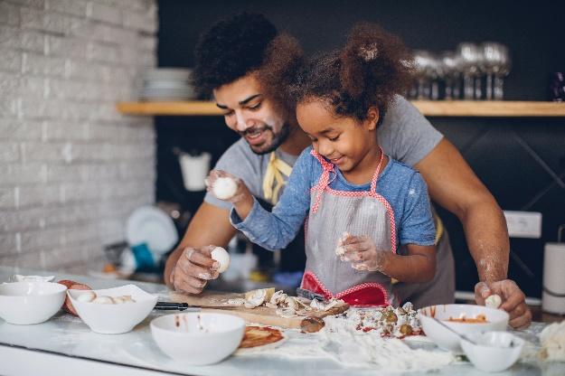
Thanksgiving is one of the few times each year when families all get together to celebrate. Over the years, your family has probably developed traditions like going to a parade, hosting dinner for your extended family, or watching your favorite football team play.
The holiday may look different this year, but that shouldn’t stop you from starting special, new traditions. Below are some ideas to try.
- Explore a Thanksgiving-themed sensory bin
Sensory bins are great for preschoolers of all ages to explore the colors, scents and textures of the season. Grab an empty bin and fill with festive items, such as leaves, water, mini pumpkins, pinecones and dried corn cobs. Don’t forget to add cups, tongs and spoons for filling and dumping.
- Create a gratitude board
Provide your child with a large poster board, family photos, magazines, markers, glue stick, and child-safe scissors, if age appropriate. Encourage him to search for photos of the people and things he is most thankful for this year. Help him write the phrase “Gratitude Board” at the top of the board, cut out the pictures and glue them down.
- Make a new dish
Find a new recipe to try this year, maybe it’s a twist on the classic mashed potatoes or a yummy new fruit pie. Get your child involved by asking him to follow multi-step directions, such as scooping, mixing and pouring ingredients. While the food is cooking, show him how you set the table and encourage him to replicate.
- Connect with family far away
You’ve probably had your fair share of video calls this year, but make an exception on Thanksgiving. You might not be able to see all your extended family members in person for the holiday. Set up a video call to make everyone feel included in your holiday festivities.

