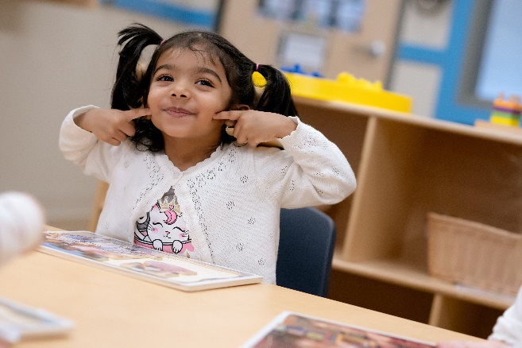
Celebrating the Joy of Learning with Week of the Young Child
April 1-7 is Week of the Young Child, which recognizes young students, their teachers, and their families for all their hard work. This annual event, sponsored by The National Association for the Education of Young Children (NAEYC), allows us to showcase the importance of early childhood education, our Links to Learning curriculum, and everyone who makes it possible.

Below is how we’re celebrating each day in our classrooms.

Music Monday
Our Week of the Young Child celebrations kick off with Music Monday. Through singing, dancing, and listening to music, our students develop language and literacy skills, self-expression, and creativity. Our teachers provide musical instruments and encourage students to practice following along to music of various tempos.

Tasty Tuesday
On Tasty Tuesday, we’re connecting literacy skills with math and science, while also encouraging healthy nutrition habits. By engaging in hands-on cooking activities, our students also develop their fine motor skills, hand-eye coordination, and cognitive abilities such as following instructions. They scoop and pour ingredients, assist in measuring, taste their cooking creations, and chart their favorites. Bon appétit!

Work Together Wednesday
Work Together Wednesday is all about emphasizing the importance of building and maintaining a positive classroom community and culture. When our students work together, they explore important academic concepts while also building their social-emotional skills like sharing and problem solving. They learn to take turns and share their ideas as they play board games, contribute to class murals, and build towers together.

Artsy Thursday
Ready, set, create! Through open-ended art activities using paint, clay, crayons and more, students use their imagination, develop fine motor skills, and gain a sense of achievement and pride. In our classrooms, teachers inspire students as they learn about various artists and types of art. Teachers focus on process-based art education, so that the experience of creating is valued beyond that of the end product.

Family Friday
On the last day of Week of the Young Child, we’re celebrating our students and their families. We partner with families throughout the year to learn about their backgrounds and traditions, and then provide books and other materials that highlight their cultures in authentic ways. Students share their celebrations and learn that all families have unique characteristics.

