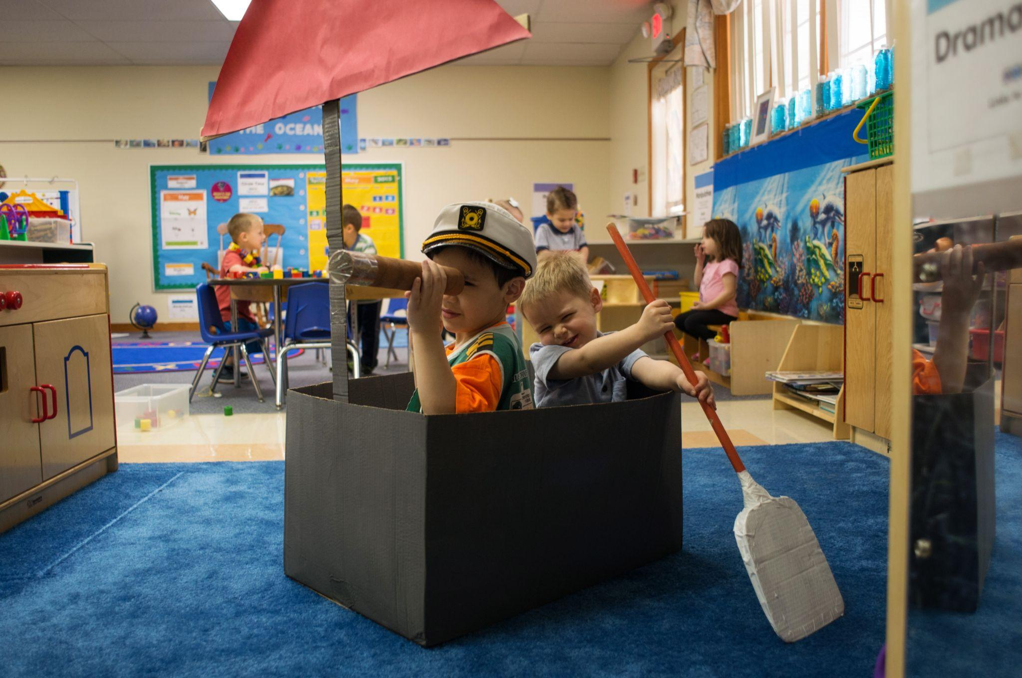
Reduce, Reuse, Recycle to Spark Creativity and Ignite Imagination
Did you know that some of the best ways for children to engage in play and get their creative juices flowing is by using everyday materials in new ways? Our teachers are always adding recycled materials to all the centers in their classrooms in hopes of planting new ideas, helping students develop an understanding of how things work, increasing their language skills, and learning about the world around them.
Research shows that children who play with recycled materials are more likely to engage in open-ended and imaginary play, have better storytelling skills, and are more creative. So, before you throw away used items, check our list below for ideas on how your child can reuse them.
Creative Expression
Paper scraps, leftover wrapping paper, paper tubes, old newspapers, popsicle sticks, egg cartons, milk bottle caps, and more can all be used to create collages, sculptures, and dioramas. Simply provide your child with these items and some glue or tape and watch them go! Add safety scissors for some cutting practice as well.
Dramatic Play
Use large cardboard boxes as playhouses, forts, and barns for stuffed animals. Medium-sized boxes can be transformed into boats, race cars, spaceships, or puppet theaters. Use smaller boxes for stacking and building to create towns. Add cars to drive through the city.
Music
Have any old pots and pans? Old coffee tins? Plastic containers from take-out food? These all make perfect drums! For the drumsticks, your child can use their hands or wooden spoons.Transform an old tissue box into a guitar by wrapping rubber bands around the opening.
STEM
Gather all sorts of loose parts – spools, cardboard tubes, nature items, plastic bottles, straws, large buttons, old phones, and calculators. Use these items for sorting, counting, building, and more!
Sensory
Take any of the STEM or art materials listed above and gather them into a bin or adhere them to a wall for a sensory experience.
Scientific Exploration
Use milk cartons, soft drink bottles, and ice cream containers as planters. Decorate the containers and add them to your garden. Tend to the plants and observe the changes with your child.
Closing tip!
Don’t forget to talk with your child about how reusing items helps our earth. Be sure to engage in conversation about reducing waste, reusing items in new ways, and recycling materials. As your child works with random items in new ways, say “Isn’t it great that instead of throwing that away, you found such a great way to use that!”

